**Date of Experiment: 24/01/25**

**Date of Submission: 24/01/25**

**SVKM’S NMIMS**

**Mukesh Patel School of Technology Management & Engineering**

Department of Mechatronics Engineering

**AR-VR Lab**

Subject- Robotic Process Automation

**EXPERIMENT NO. 2A**

**Objective:**

This lab manual aims to reinforce your understanding of Power Automate Desktop, emphasizing variables for data manipulation and conditional actions for dynamic decision-making, ultimately enabling you to construct more flexible and efficient automation flows.

**Prerequisites:**

1. Power Automate Desktop installed on your computer.

2. Basic understanding of Power Automate Desktop interface.

**Challenge Overview:**

In this experiment, you will create 3 flows

1.Takes input for three subject marks, calculates their average.

2.Checks if the number is above the passing threshold

3.Assigns grades based on the number input from the user.

**Important Actions:**

**1. Input Dialog:**

- Use the "Input Dialog" action to prompt the user to enter marks for three subjects.

- Configure the input dialog to request numerical input for each subject.

**2. Calculate Average:**

- Utilize the "Set Variable" action to sum the three subject marks obtained from the user.

- Divide the sum by 3 to calculate the average.

**Hint:**enclose the calculation in “%%” any thing inside this will be evaluated.

**3. Decision:**

- Insert a "Decision" action to evaluate whether the average is above the passing threshold.

- Configure the decision to have two branches - one for passing and another for failing.

-You may use If-else or switch case here

**4. Assign Grades:**

- In the passing branch, use the "Set Variable" action to assign the appropriate grade based on the average.

- For example, if the average is above a certain value, assign 'A'; if it's between another range, assign 'B', and so on.

- In the failing branch, you may choose to assign an 'F' grade.

-You may use If-else ladder or switch case here

**5. Display Results:**

- Use the "Message Box" action to display the calculated average and assigned grade to the user.

**Tasks:**

1. Create a Power Automate Desktop flow that incorporates the described actions.

2. Test the flow by providing different sets of marks to ensure accurate calculation and grade assignment.

3. Debug and troubleshoot any errors that may arise during the execution of the flow.

4. Optimize the flow for efficiency, considering factors such as readability and simplicity.

**Flow Screenshots:**

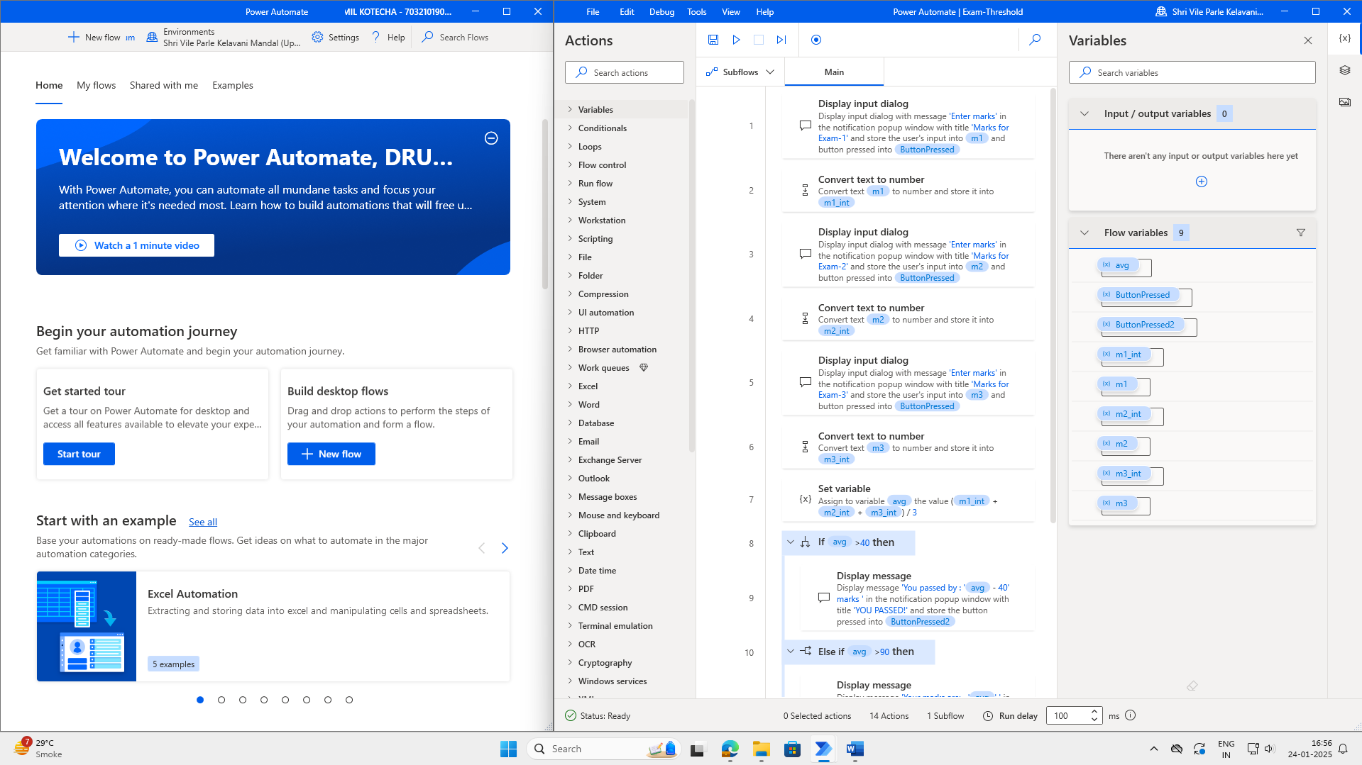

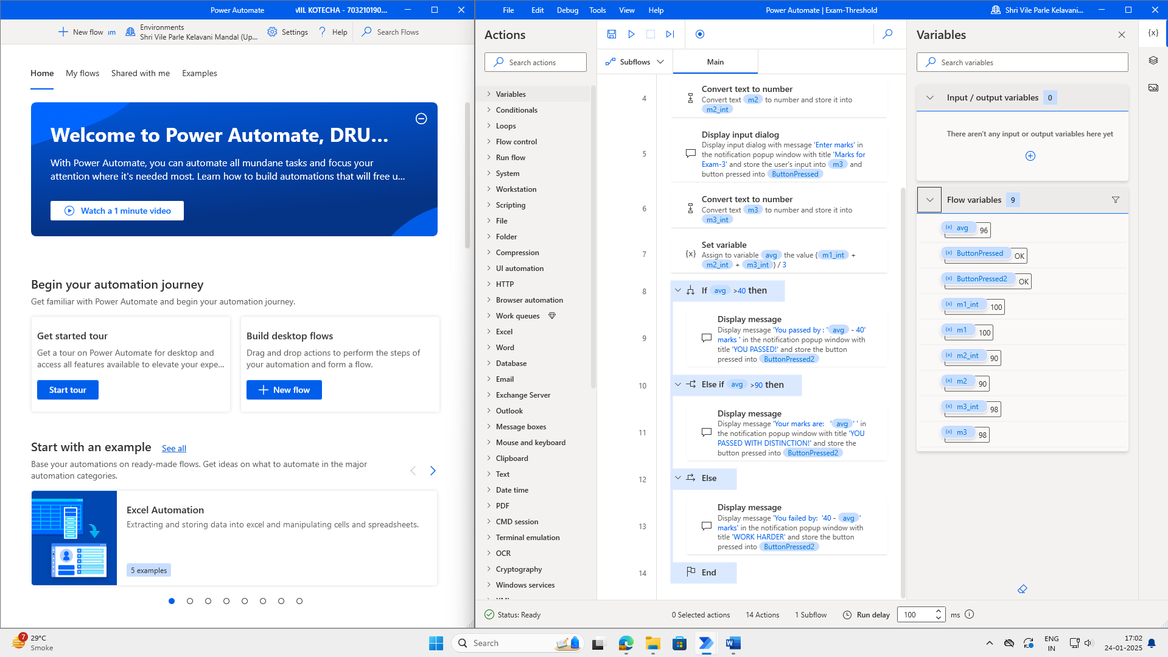

**Input Screenshots:**

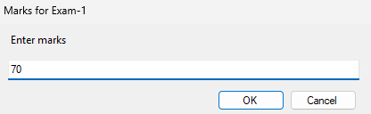

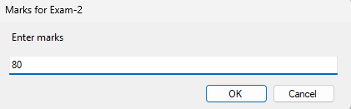

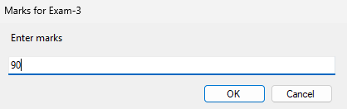

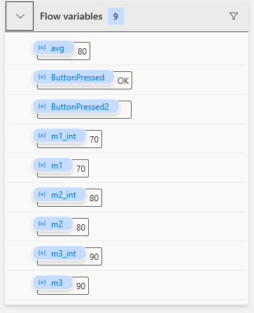

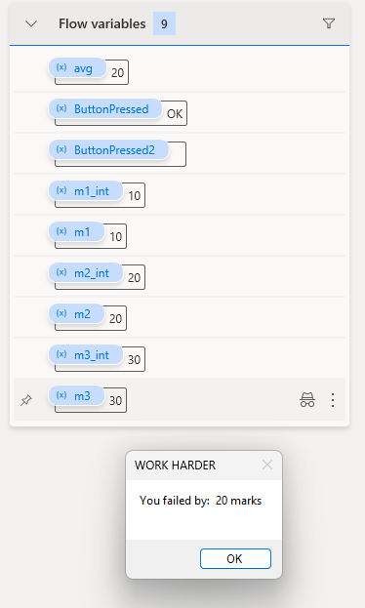

**Output Screenshot:**

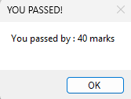

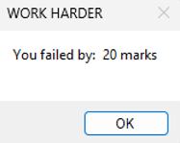

**Conclusion:**

I gained a clear understanding of how to apply if-else conditions in Power Automate by developing a flow for grade calculation. Additionally, I utilized various utility actions, such as the ‘Convert text to number’ action, to facilitate performing necessary calculations and operations within the flow.